PUSH NOTIFICATION GUIDE:
- After creating new gmail account for the app, go to firebase console and click “Create project”
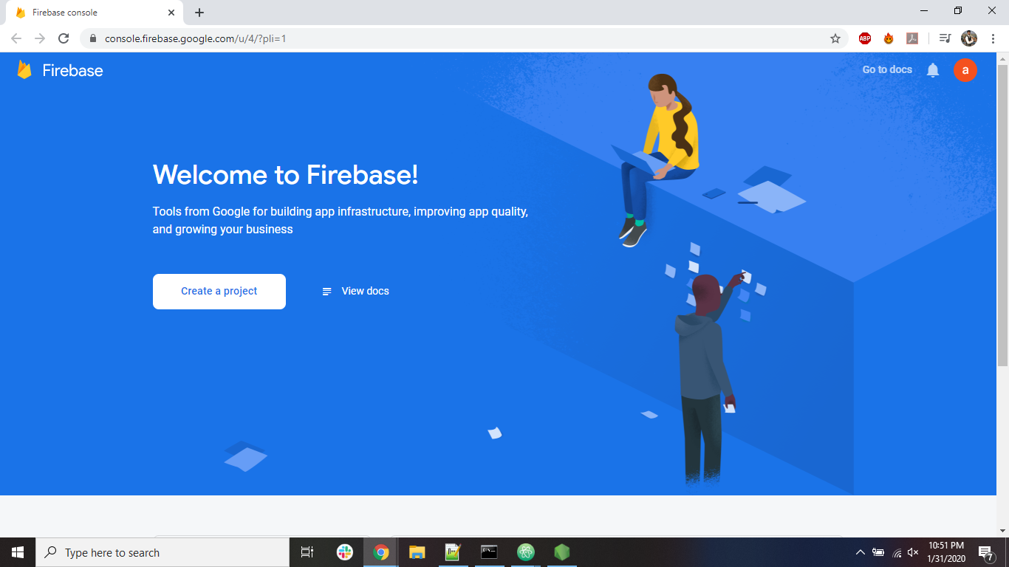

- On filing some simple info, you will be logged in to dashboard of firebase.
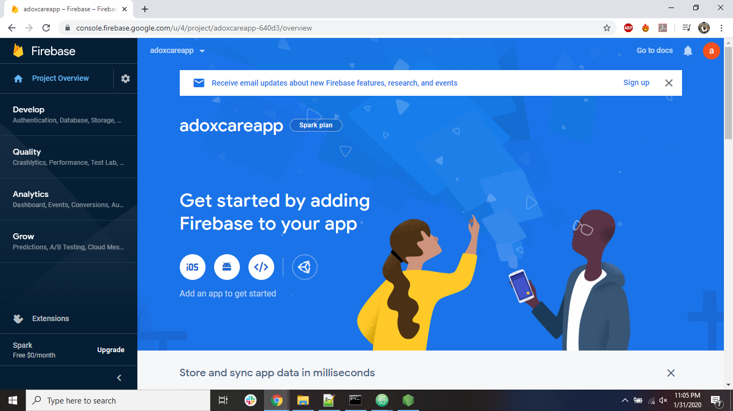
- On clicking the android icon from the dashboard, you will get this screen. Important: Please double check the app package name and fill in the first box. And other optional info if you want.
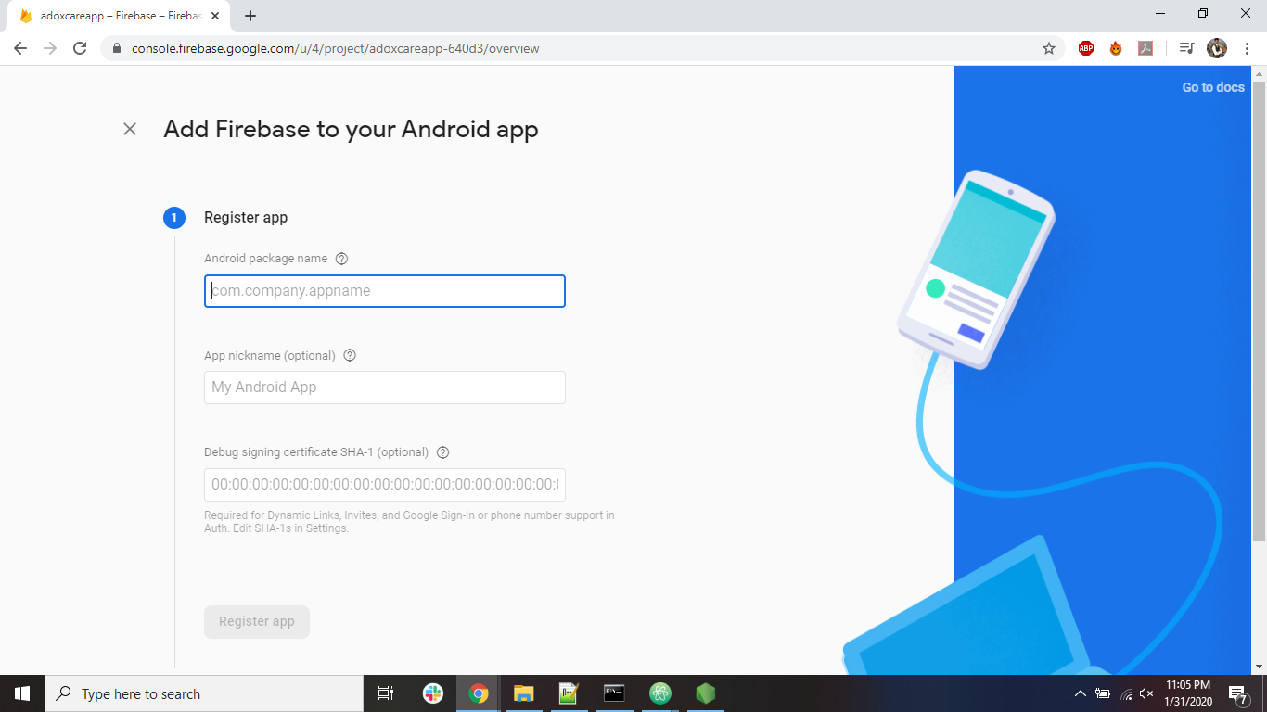

- After adding the android app :
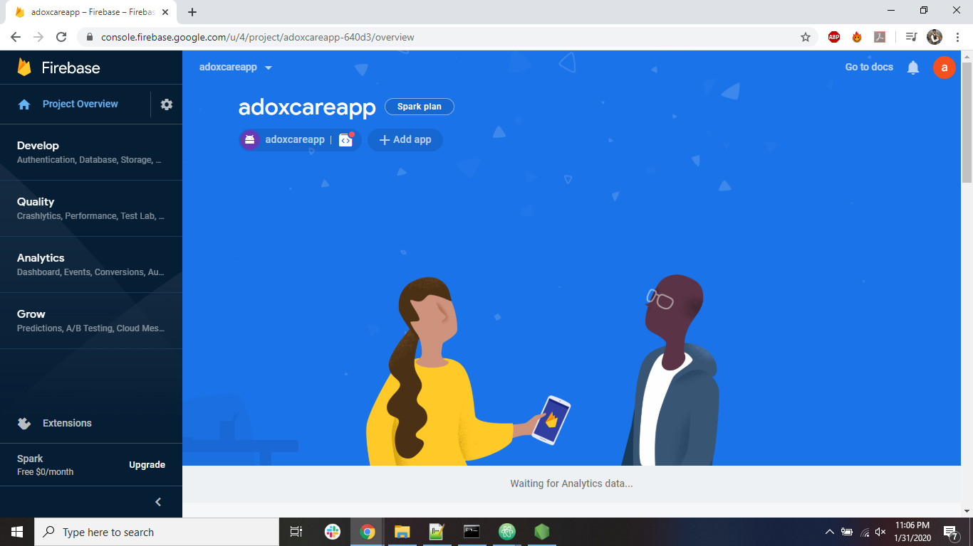

- On the right side of the project Overview menu, click on the setting and choose project settings.
Configure your app here. Add the fingerprint (SHA1 key) of your laptop which varies from laptop to laptop. Keep both debug key and your custom key which is to be used in the release app.
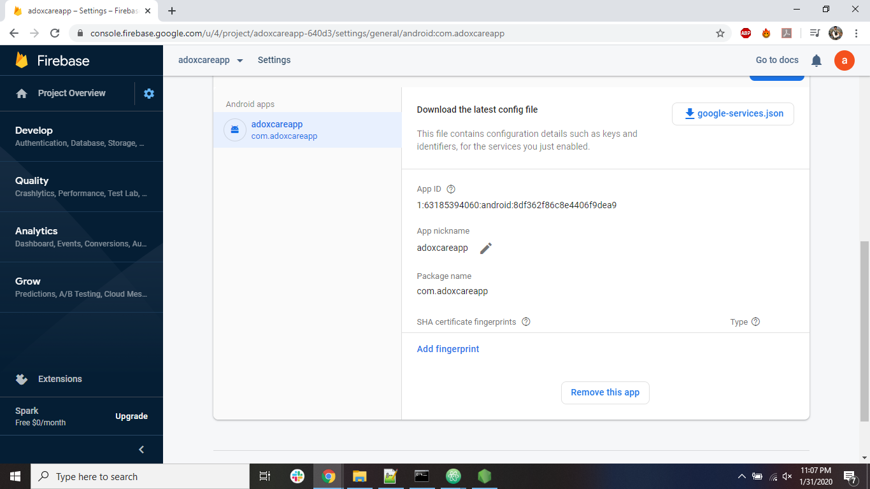

8. For SHA1 Fingerprint KEY:
1. Android keystore for a DEBUG apk.
=> Open cmd from "C:\Users\kamle\.android" dir.
=> request new keystore file:
keytool -genkey -v -keystore debug.keystore -storepass android -alias androiddebugkey -keypass android -keyalg RSA -keysize 2048 -validity 10000
=> View details of new keystore file:
keytool -list -v -keystore debug.keystore -alias androiddebugkey -storepass android -keypass android

2. Android keystore for a RELEASE apk.
=> Open cmd from android\app dir.
=> request new keystore file:
keytool -genkey -v -keystore mykeystore.keystore -alias mykeyalias -storepass adoxcare -keypass adoxcare -keyalg RSA -keysize 2048 -validity 10000
=> View details of new keystore file:
keytool -list -v -keystore mykeystore.keystore -alias mykeyalias -storepass adoxcare -keypass adoxcare

9. After filing the SHA1 key, download the googlejson file, the blue text with download icon. And place it in the android/app directory.
10. Under the grow tab on the side menus, find cloud messaging and create new notifications for all the users.
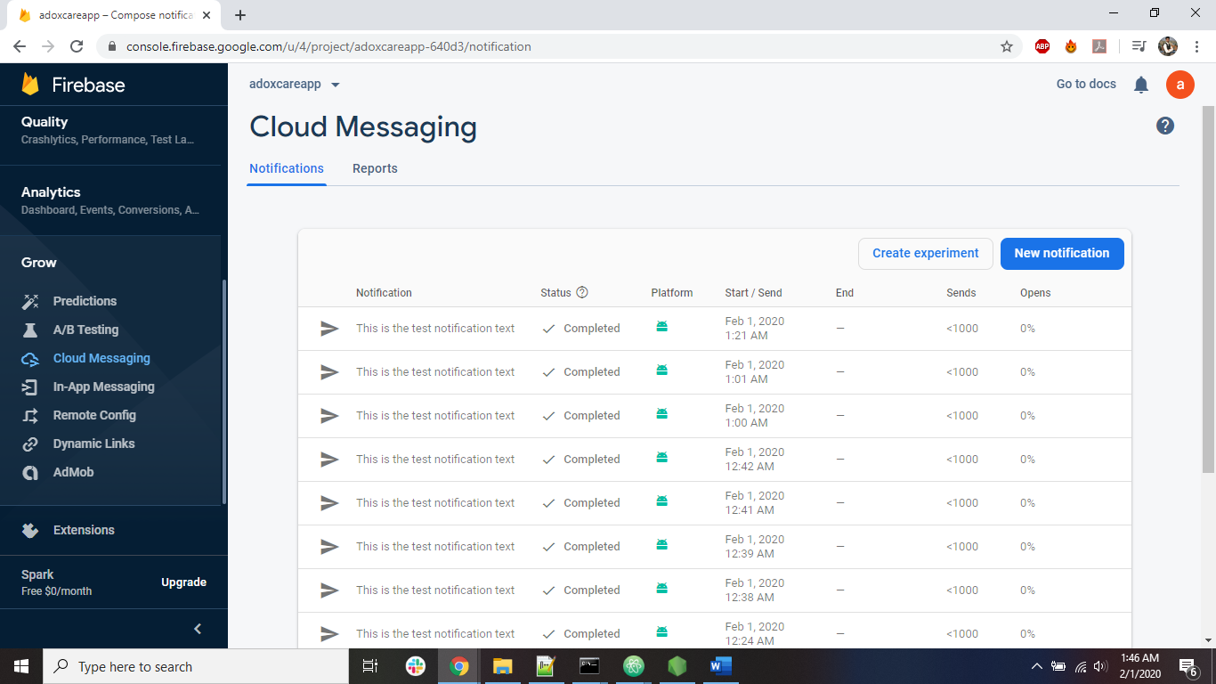

11. For knowing the changes in the code. Please refer the commit on the github.

